**Download/Sort/Convert/Preprocess/QC Raw Data**

**Required Software**: Filezilla (or another FTP software), Horos, Matlab, MRIcoGL

1. **Download raw data from CBIHome**
   1. Access CBIHome through an FTP client (requires MUSC wifi or VPN)
      1. sftp://cbihome.musc.edu
      2. Log in with NETID and PW
   2. Navigate to MRdata folder

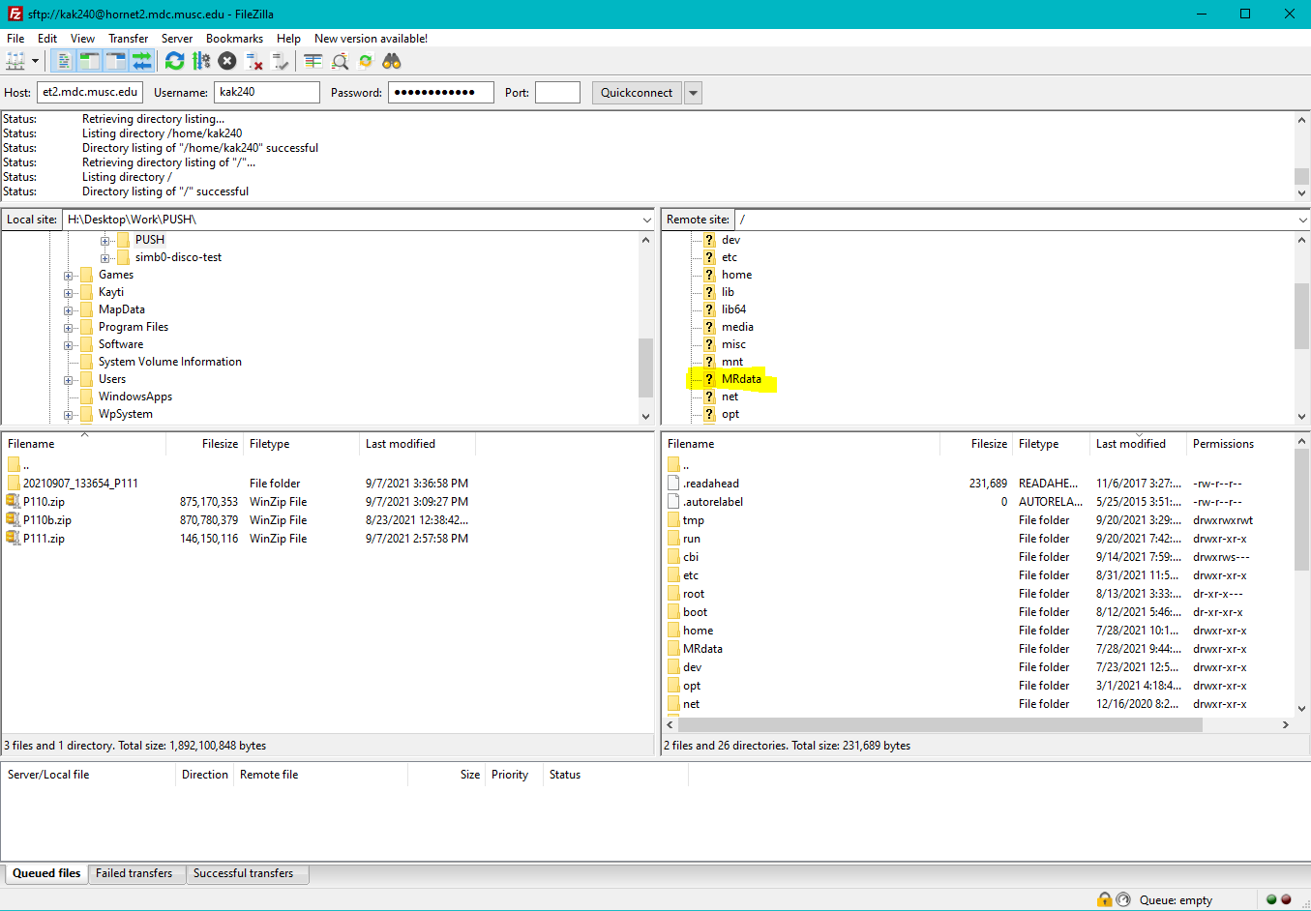

* 1. Navigate to the folder of the PI of the study, then to the study folder, then click on the ‘upload’ folder
  2. You will see a series of .zip folders, download whichever you need.

1. **Raw data QCing**
   1. Unzip the .zip dicom folder
   2. Open Horos and drag the entire unzipped dicom folder into the program
      1. Select ‘copy the links’
2. **Sort and convert raw dicoms**
   1. Sort dicoms using the script dicom_sort_and_convert.m
      1. Note: there are other ways of sorting, this is just a simple, easy to use/troubleshoot script
   2. Convert raw data from dicom to nifty using dcm2niix
      1. There are many ways to name converted files using dcm2niix flags
         1. Using the flags –f %p is a good standard way of converting with comprehensible file names